**MATHS-X (SA-II)**

**General Instructions:**

**(i) All questions are compulsory.**

**(ii) The question paper consists of 31 questions divided into four sections A,B,C and D .Section A**

**comprises of 4 questions of 1 mark each. Section B comprises of 6 questions of 2 marks each,**

**section C comprises of 10 questions of 3 marks each and Section D comprises of 11 questions of**

**4 marks each.**

**(iii) There is no overall choice.**

**(iv) Use of calculators is not permitted.**

**(v) An additional 15 minutes time has been allotted to read this question paper only.**

**Section -‘A’**

1. If b = a + c, then the equation 

(a) real root (b)no real roots (c)equal roots (d)one real root

2. If AP, AQ and tangents to the circle, then BC is equal to:

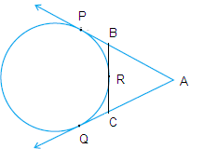

(a)BR+BP (b) BP+CQ (c)AB+CQ (d)AC+BP

3. Length of tangent drawn from point 8 cm away from the centre of a circle of radius 6 cm is:

(a) 10 cm (b)  (c)  (d) 5cm

4. Two vertical poles are 50 m apart .The angle of depression of the top of the first as seen from the top

of the second is 450.If the height of the second pole is 100 m,then the height of the first pole is:

(a)200m (b) 150 m (C) 75 m (d)50 m

5. The probability of getting two tails when two coins are tossed together ,is:

(a)  (b)  (c)  (d)1

6. In a throw of a die, the probability of getting a prime number is:

(a)  (b)  (c)  (d) 

7. If A one of the point of trisection of segment joining B and C, then A divides BC in the ratio of:

(a)2 :1 or 3:1 (b) 1:2 or 3:1 (c) 1:3 or 3:1 (d) 1:2 or 2:1

8. The angle through which the minute hand of a clock moves from 8 AM to 8:35 AM is :

(a)2100 (b)900 (c) 600 (d) 450

9. If one roof of the quadratic equation is twice the other root, find the value of q.

**Section -‘B’**

10. If are root of the quadratic equation 

11. DA and DB are the tangents drawn from D, to the circle with centre O,at A and respectively .If



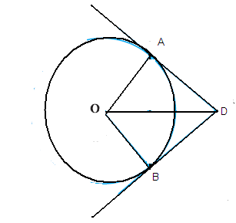

12. FG is tangent to the circle with centre A. If and

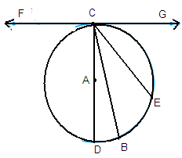

13. A card is drawn from a well shuffled deck of 52 cards .Find the probability of getting

(a)A king of red colour. (ii)a jeck of hearts

14. A cylindrical tank has a capacity of 6160 cu.m.Find its depth, if its radius is 14 m. Calculate the cost of

painting its curved surface (outer ) at the rate of Rs 3/m2.

**Section -‘C’**

15. Solve for 

16. Solve the quadratic equation by the method of completing the squares

17. Prove that the tangents drawn from an external point to a circle are equal.

18. Solution A and B are km apart .Each station sights an airplane at angle of elevation 300

and 450 as shown in figure .Find the altitude of the airplane.

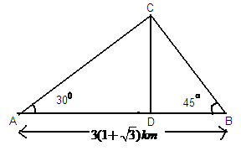

19. The two vertices of an equilateral triangle are (-2, 0) and (2, 0), Find the third vertex.

20. Find the area of a triangle having vertices as .Justify your

answer.

21. A toy is in the form of cone of radius 3.5 cm mounted on a hemisphere o same radius. The total

height of the toy is 15.5 cm.Find the total surface area of the toy.

22. Find the area of the shaded region in figure, if PQ=24 cm, PR=7cm and O is the centre of the circle.

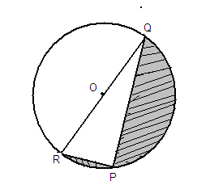

23. A gulab jamun contain sugar syrup up to 35% of its volume .Find approximately how much sugar

syrup would be found in 20 gulab jamuns ,each shaped like a cylinder with hemispherical ends with

total length 7 cm and diameter 3 cm.

24. If h,c and v respectively are the height ,the curved surface area and volume of cone ,then prove that



**Section -‘D’**

**SECTION’D’**

25. Solve for 

26. In an A.P .the first term is 22,nth term is -11 .The sum to first n terms is 66.Find number of terms ‘n’

and common difference ‘d’ and A.P.

27. Doctors advise brisk walking in the morning, to remain fit .If a person had walked 1km/h faster, he

would have taken 15 minutes less to walk 3 km .Find the original rate of his walking.

28. Construct two tangents PT and PQ to a circle of radius 4 cm and centre O such that

29. Construct aConstruct another ∆similar to it whose

side are times of the corresponding sides of the first ∆.

30. A man standing on the deck of a ship is 12 m above water level .He observes that the angle of

elevation of the top of a cliff is 450 and the angle of depression of the base of the cliff is 300.

Calculate the distance of the cliff from the ship and the height of the cliff.

31.A box contains 5 blue ,3 white and 4 black marbles .If a marble is drawn at random from the

box, what is the probability that it will be

(i) white (ii) not blue (iii) black or white (iv) neither white nor blue.

32. In what ratio does line 4x + 3y – 13 = 0 divide the line segment joining the points (2,1) and (1,4).

33. The radius of a circle is 17.5 cm.Find the area of the sector enclosed by the two radii and an are of 44

cm is length.

34.A solid iron pole having a cylindrical portion 110 cm high and of base diameter 12 cm surmounted by

an iron cone of height 9cm .Find the pole ,given that mass of 1 cm3 of iron = 8 grams.